# Use Case Specifications

## Use Case Model

Golf Course Manager

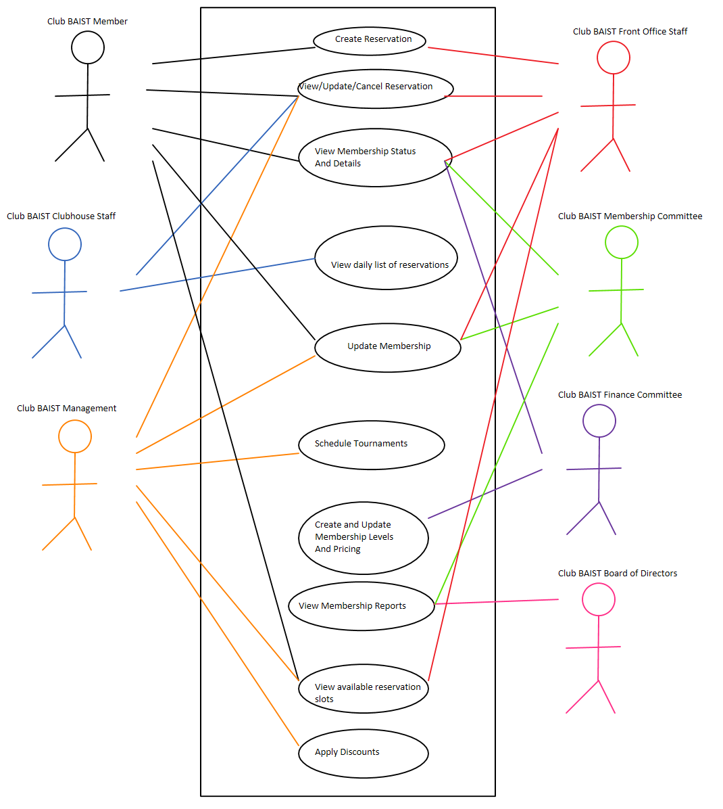

## Use Case Descriptions

### Create Reservation

The Club BAIST Member wishes to reserve a tee time for themselve and up to 3 other people. The desired time slot must be available and the Club BAIST Member must be in good standing. The desired time slot must be for a future date (same day is not allowed). If successful, the system will mark that time slot as reserved by the Club BAIST Member. This use case will also be available to Club BAIST Front Office Staff who can create reservations for Club BAIST Members who call in over the phone or who are in the office. This use case will need to be able to create a recurring standing reservation.

### View/Update/Cancel Reservation

The Club BAIST Member wishes to view or cancel or update their current reservation. Cancelling or changing the time of a reservation will free up that time slot for use by other Club BAIST Members. Club BAIST Clubhouse Staff will be able to mark the reservation as fulfilled when the Club BAIST Member tees off on time. Club BAIST Front Office Staff will be able to use this use case on behalf of Club BAIST Members. Club BAIST Management will be able to use this use case when needed.

### View Membership Status and Details

The Club BAIST Members will be able to review their membership status and their demographic information. This will allow them to view important details like whether their applications have been approved, payments have been accepted, and so on.

### View Daily List of Reservations

The Club BAIST Clubhouse Staff need to be able to print a list of the days’ time slots. They will mark each reservation as fulfilled as the Club BAIST Member tees off. This list should have the Club BAIST Members and their party’s names.

### Update Membership

Club BAIST Members and Club BAIST Front Office Staff will be able to update their contact and demographic information as well as change the Club BAIST Members level through this use case. The Club BAIST Membership Committee and Club BAIST Management will use this use case to approve and cancel memberships.

### Schedule Tournaments

Club BAIST Management needs to be able to create large blocks of reservations easily for tournaments. If a time slot is already occupied by a prior reservation that reservation will be automatically cancelled.

### Create and Update Membership Levels and Pricing

The system needs to be flexible enough to accommodate changes to the membership levels and their pricing. This use case will be available to the Club BAIST Finance Committee. The updated membership levels and pricing will be reflected on the next invoice for Club BAIST Members.

### View Membership Reports

The Club BAIST Finance Committee and the Club BAIST Board of Directors need to be able to review how the Club BAIST Golf Club is performing. What reports are required have not been determined yet but will likely include monthly approved memberships, monthly total memberships broken down by Membership Level and Club BAIST Members who have not paid their dues.

### View Available Reservation Slots

Club BAIST Members, Club BAIST Front Office Staff and Club BAIST Management need to be able to view the available Time Slots for a given day. From there the person using this use case will be able to create a reservation. If a Time Slot is currently reserved by a Club BAIST Member with a lower Membership Level than the Club BAIST Member using the use case, that Time Slot will be shown as available. If Club BAIST Management is using this use case, the reserved Time Slots will show the name of the Club BAIST Member who has reserved that Time Slot.

### Apply Discounts

Club BAIST Management needs to be able to apply discounts to in case of Club BAIST Member complaints. The discounts will only apply to membership fees.